

**Ohio Has $33.8B In Shale Projects**

**Decrease in Drilling Not Hindering Development**

**November 15, 2015**

The Intelligencer / Wheeling News-Register

By CASEY JUNKINS

Staff Writer

ST. CLAIRSVILLE - Counting the proposed $5.7 billion PTT Global Chemical ethane cracker plant along with tens of billions of dollars in processing infrastructure from MarkWest Energy, M3 Midstream and Blue Racer Midstream, Marcellus and Utica shale activity accounts for $33.8 billion worth of economic development in Ohio, a Columbus-based law firm determined.

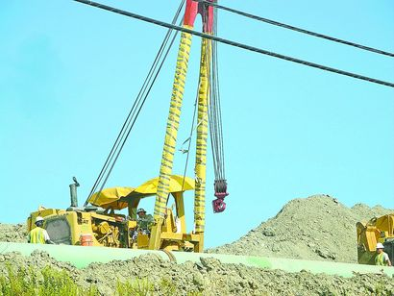

File photo  
Data from the Columbus-Ohio based Bricker & Eckler law firm show there are $33.8 billion worth of Marcellus and Utica shale related development projects now planned in the state.

The projects tabulated by the Bricker & Eckler law firm also include the $1.1 billion Southfield Energy power plant scheduled for Columbiana County, numerous pipeline projects crossing the state, and even new housing, hotel and retail developments officials believe are happening in Ohio specifically because of the burgeoning shale boom.

"Not only do we continue to see new projects, but the level of investment continues to be significant - in the billions. Ohio continues to reap the benefits of active, ongoing and new development in the energy sector," Matt Warnock, Bricker & Eckler partner and co-chair of the law firm's Oil & Gas Industry Group, said.

"Since we began tracking shale development two years ago, growth has been consistently on the rise," he added.

The $33.8 billion invested in Ohio does not include the additional tens of billions of dollars invested and planned in West Virginia's Northern Panhandle.

Despite a slowdown in drilling and fracking across the region due to natural gas and oil prices dropping over the last year, this does not seem to hinder overall development in Ohio.

Industry leaders believe more pipeline infrastructure is needed to get their products to market.

Bricker & Eckler counts the $4.4 billion Rover Pipeline that will stretch across the state among the projects, as well as the $1.75 billion Leach XPress pipeline. Also on the list is the ATEX Express ethane pipeline at a cost of more than $1 billion.

Other projects included on the list include:

-- a $400 million gathering system for XTO Energy in Monroe and Belmont counties;

-- the $900 million Carroll County Energy natural gas power plant;

-- $6.4 million for a compressed natural gas filling station in Columbus;

-- $100,000 in scholarships for those studying the oil and natural gas industry at Eastern Gateway Community College;

-- $415 million for the EQT Corp. Ohio Valley Connector pipeline system in Monroe County;

-- $2 billion for the NEXUS Gas Transmission system that would send gas across Ohio; and

-- several millions dollars for the numerous hotel and housing projects built to accommodate the influx of oil and natural gas workers.

The increased shale investment is paying off for local communities. The Wheeling Metropolitan Statistical Area - which consists of Ohio, Marshall and Belmont counties - saw its gross domestic product grow by 9.5 percent from 2013 to 2014, according to data provided by the U.S. Department of Commerce.

Natural gas and mining account for the vast majority of the economic growth for the MSA.