

**Chesapeake Triples Its Utica Production**

**March 2, 2014**

By CASEY JUNKINS - Staff Writer , The Intelligencer / Wheeling News-Register

[Save](http://www.theintelligencer.net/?page=mscontent.saveContentMsg&showlayout=0&id=596621&nav=515) | [Comments (**3**)](http://www.theintelligencer.net/page/content.comment/id/596621/Chesapeake-Triples-Its-Utica-Production.html?nav=515) | [Post a comment](http://www.theintelligencer.net/page/content.comment/id/596621/Chesapeake-Triples-Its-Utica-Production.html?nav=515) |

ST. CLAIRSVILLE - Average daily natural gas output from Chesapeake Energy's Utica Shale operations jumped to 189 million cubic feet during 2013, reflecting a 309 percent increase from from 2012.

The Oklahoma City-based fracker, which remains the most active in the Upper Ohio Valley, reported a loss of $159 million for the three-month period ending Dec. 31. However, for the entire year of 2013, Chesapeake recorded net income of $474 million.

Chesapeake CEO Doug Lawler said 2013 was a, "foundational year in which we focused on optimizing our business processes, implementing a disciplined capital budget, decreasing per unit cash costs, selling non-core assets and reducing liabilities."

**Article Photos**

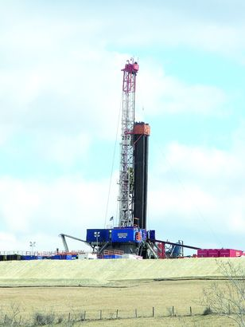

Photo by Casey Junkins  
With a regional field office in St. Clairsville and fracking operations in both Ohio and West Virginia, Chesapeake Energy remains the most active driller in the Upper Ohio Valley.

Lawler said 2013 was "transformational" for Chesapeake, as the year saw: company founder and former CEO Aubrey McClendon resign from the firm to form his own company, American Energy Partners; the company shed about 65,000 acres in Texas and Louisiana to raise $1 billion in cash; Chesapeake eliminate 60 jobs from its Uniontown, Ohio office, as well as many employees who had been working in the Ohio Valley; and the firm agreed to pay $9.7 million worth of fines and restoration costs for environmental damage in Marshall and Wetzel counties.

"In 2014, we plan to reduce drilling and completion costs, before drilling carry credits, by nearly $900 million, while still generating comparable production growth year over year," he said.

As of Dec. 31, Chesapeake had drilled a total of 425 Utica wells, with 230 of these in the production stage and 195 awaiting pipeline connections.

In the Marcellus Shale spanning West Virginia and Pennsylvania, Chesapeake reached daily production of 285 million cubic feet during 2013, reflecting an 82-percent increase from 2012. The approximate composition of this Chesapeake Marcellus gas stream is:

- 70 percent dry methane gas;

- 18 percent natural gas liquids, such as ethane, propane, butane and pentane; and

- 12 percent oil.

The company previously reported oil production in both Ohio and Marshall counties.

Chesapeake plans to spend up to $5.6 billion for drilling and fracking this year, which represents a 20-percent reduction from the levels company officials originally scheduled to spend in 2014. However, company officials believe their investments over recent years will start to pay off, as they anticipate growing natural gas liquids production by 49 percent from 2013 levels.

"We are continuing to review and refine our portfolio for assets that fit best with the company's strategy of profitable growth from captured resources and expect to have additional asset dispositions in 2014,"Chief Financial Officer Domenic J. Dell'Osso Jr. said

[© Copyright 2014 The Intelligencer / Wheeling News-Register. All rights reserved. This material may not be published, broadcast, rewritten or redistributed.](http://www.theintelligencer.net/page/content.detail/id/596621/Chesapeake-Triples-Its-Utica-Production.html?nav=515#license-596621)