

5 cities where wages are soaring

July 29, 2014

Nationwide, average weekly pay flattened out last year. But workers in these metro areas saw big gains, driven by the construction and manufacturing industries.

[By Alexander Kent and Alexander E.M. Hess, 24/7 Wall St.](http://www.247wallst.com/)

[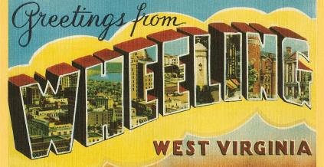](javascript:void(0);)

**No. 4: Wheeling, West Virginia**

**1-yr. wage growth**: 8.7 percent  
**Average weekly wage:** $802  
**1-yr. unemployment rate change**: -0.9 percent  
**1-yr. employment rate change**: 0.8 percent

Wages in Wheeling not only grew in 2013, but also grew faster as the year went along. In the first quarter of last year, wages were up 4.2 percent compared to the first quarter the year before. By the fourth quarter of last year, that figure had risen to 8.7 percent.

The area's unemployment rate was 6.2 percent in May, effectively unchanged from the 6.6 percent rate 12 months earlier. By comparison, in that same time frame, the national unemployment rate fell by 1.2 percentage points, from 7.3 percent to 6.1 percent. Nonfarm jobs in the area were also little changed, growing from 66,900 in 2012 to 67,600 in 2013.

Construction -- particularly among specialty contractors -- may have been the force driving high wage growth.